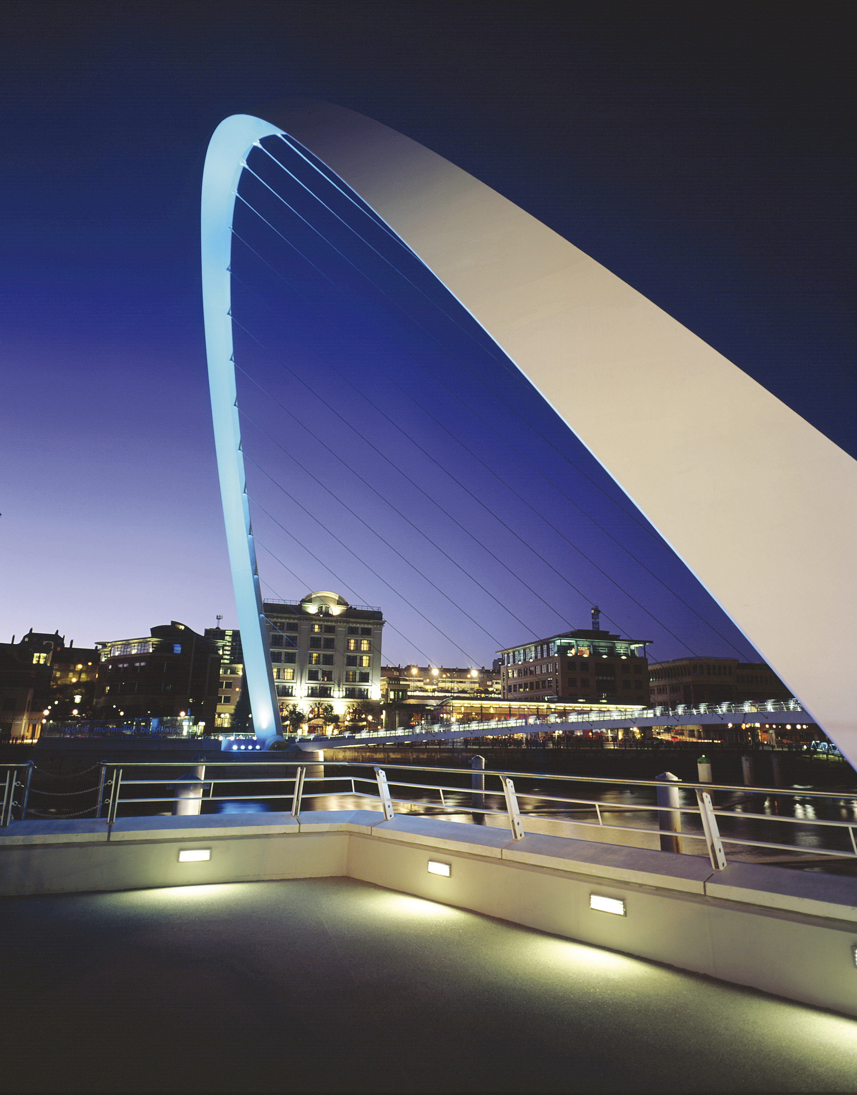
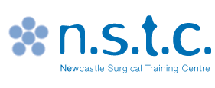
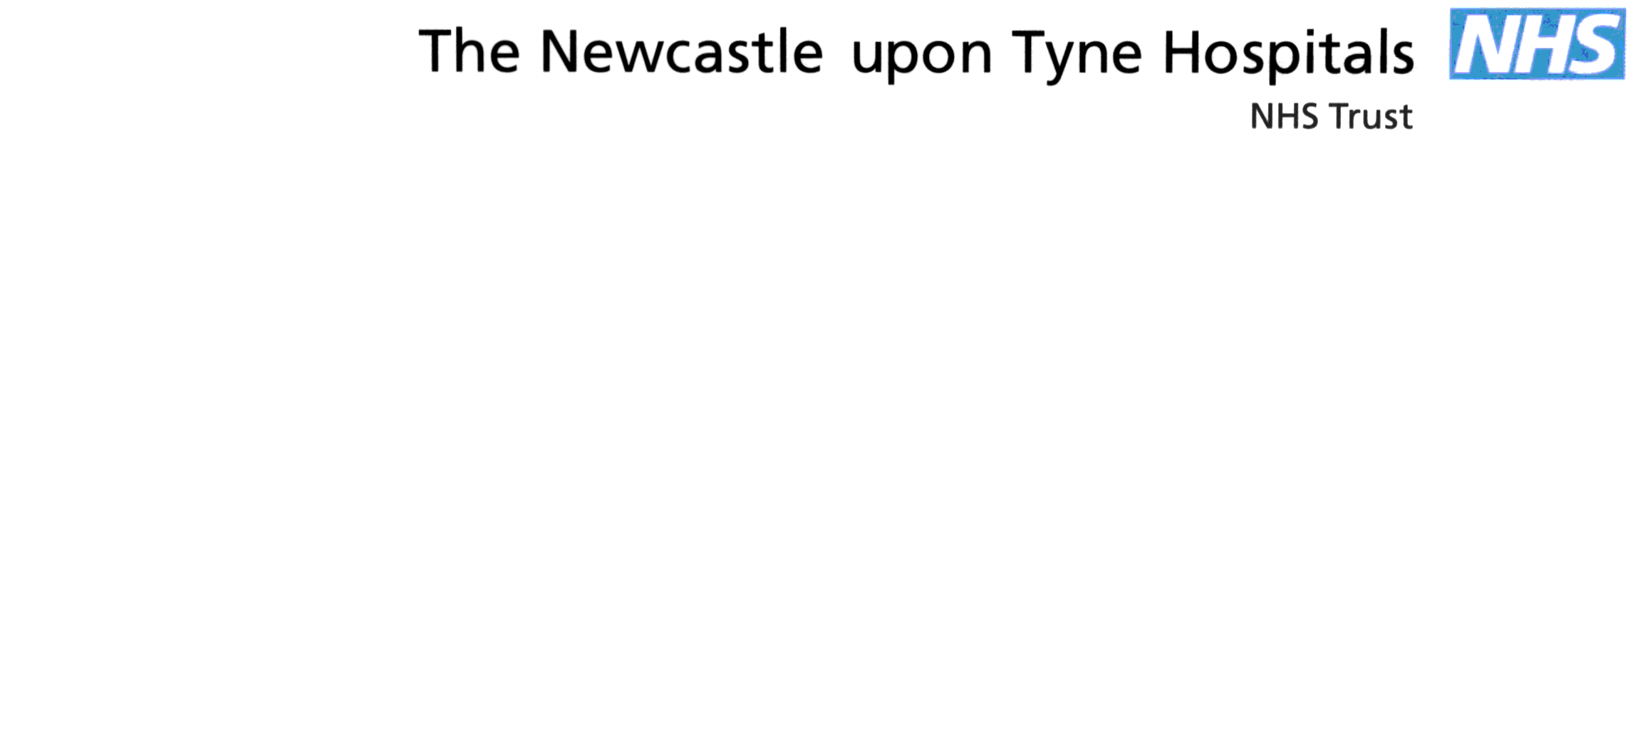

NEWCASTLE SURGICAL
TRAINING CENTRE


Pituitary Gland Surgery Course
12th June 2014 mergency Surgery course (ACTS)

FACULTY
mergency Surgery course (ACTS)

Mr Sean Carrie | Consultant ENT Surgeon, Newcastle upon Tyne NHS Trust
Alastair Jenkins | Consultant Neurosurgeon, Newcastle upon Tyne Hospitals NHS Trust
John Hill | Consultant ENT Surgeon, Newcastle upon Tyne Hospitals NHS Trust
Claire Nicholson | Consultant Neurosurgeon, Newcastle upon Tyne Hospitals NHS Trust
Mr Saurabh Sinha | Consultant Neurosurgeon, Sheffield General Hospital
Mr Alex Poluzza | Consultant Neurosurgeon, Birmingham Heartlands Hospital

Pituitary Gland Surgery Course
mergency Surgery course (ACTS)

09:30- 09.45 | Welcome & Refreshments | Sean Carrie
09:45 – 10:30 | Endoscopic anatomy/instruments tutorial | Sean Carrie
10:30 – 10:45 | Refreshments NSTC COFFEE AREA
10:45 – 12:45 | Endoscopic Skull base approaches | Wet Lab
12.45– 13:15 | Lunch NSTC COFFEE AREA
13:15 – 14.00 | Transcranial anatomy/instruments tutorial | Alistair Jenkins/Claire Nicholson
14.00-16.00 | Open Dissection | Wet Lab
16.00-16.30 | Open Forum, Evaluation and Close | All Faculty

NOTES

NOTES

